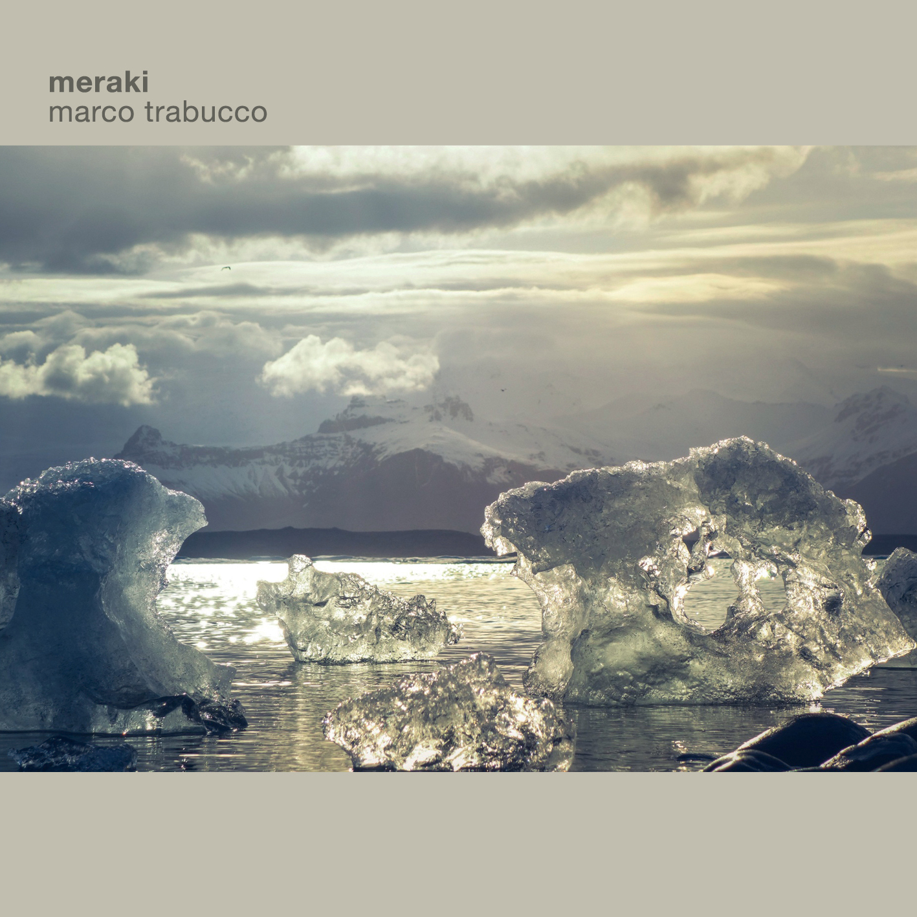

MARCO TRABUCCO – meraki
(Artesuono records 2019)

Federico Casagrande: guitar
Giulio Scaramella: piano
Marco Trabucco: double bass / compositions
Luca Colussi: drums

Meraki is the new project by Italian double bass player Marco Trabucco.
Meraki is a Greek word difficult to translate because it holds undertones connected to passion: a feeling of devotion in something. As he said: «Chose this title was a chance; I was reading a book about this and I felt like it was the perfect term to describe what I’m looking for in music».

Trabucco is the author of each composition, except for Romanza, a Spanish popular theme.
The key of his work is clear: «I wrote the most part of these tracks at the piano; I had an idea of sound from which I started and I tried to imagine how musicians I chose could be able to interpret melodies and where they could feel comfortable playing soloistic parts».

The quartet lead the listener in a deep and delicate journey thanks to the precious contribution by Federico Casagrande on guitar, Giulio Scaramella on piano and Luca Colussi on drums. They weave a completed trio from time to time which creates suggestive scenarios, full of that phatos that Trabucco has already been able to demonstrate in the previous A long trip/ with you (Abeat 2016).

Meraki is an album that finds its roots in music by contemporary musicians; Trabucco said: «When I wrote these pieces I was listening to Jakob Bro, Brad Mehldau, Wolfgang Muthspiel and I think that their idea of sound inspired me».
He takes inspiration from jazz, contemporary music but also from different fields, trying to extend boundaries, avoiding the ‘litterariness’ of those genres. This work combines mind, research on sound and tells a story, enlarging the possibilities of the young Italian jazz scene.

“... This group has experience and taste to sell and put them at the service of musical narration, musicians endowed with a solid technique, but never ostentatious ..." (Enzo Pietropaoli)

TRACK LIST
1. Untitled
2. Open space
3. Meraki
4. Flavia
5. Tale for a princess
6. One for Max
7. Romanza

CREDITS
Mixed and mastered by Stefano Amerio at Artesuono Studio, Cavalicco (UD), produced by Stefano Amerio for Artesuono records.

For links of the album (listening only) please see the other attachment.

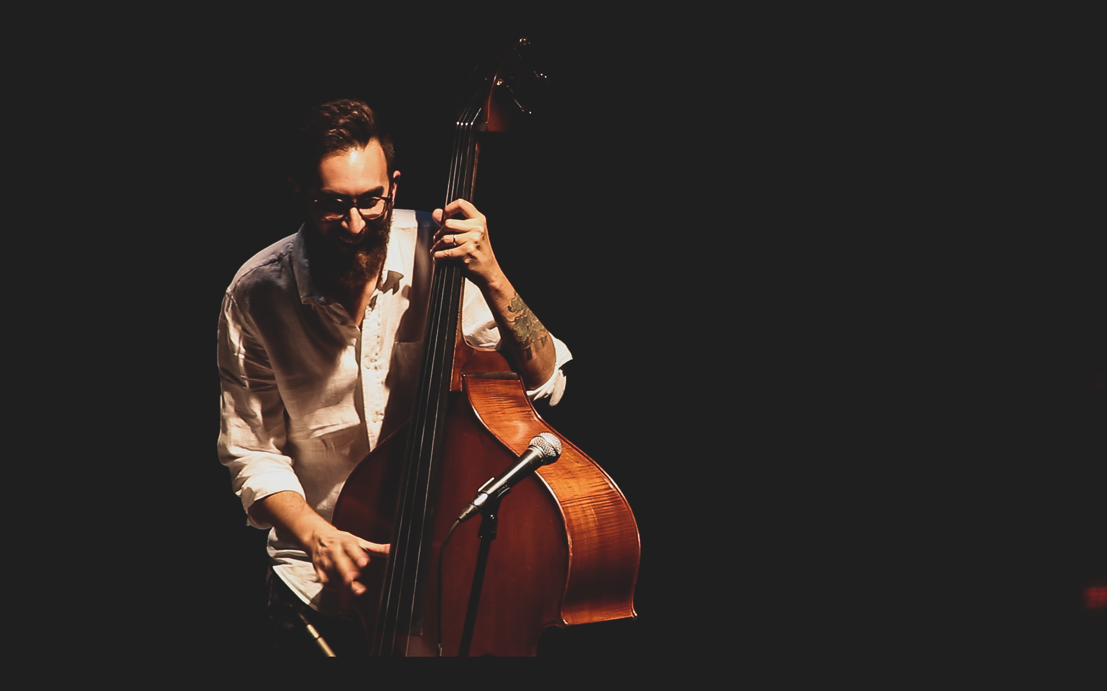

Marco Trabucco is an Italian jazz electric bass player, double bass player and composer.
He has a BA at Conservatorio “G. Tartini”, Trieste and a MA at Conservatorio “A. Stefani” in Jazz.
He studied with Jarrod Cagwin, Bjorn Meyer, Klaus Gesing, Norma Winstone, Curtis Lunday, Dennis Chambers, Salvatore Maiore and many others.
In 2010 he won the first prize at International Prize “Young Musicians” (jazz session) and he began a project with his brother and drummer Max Trabucco; they recorded Open/Close (Blue Serge Records 2010) and Orchestra (Caligola Records 2011).
In 2013 he participated to the “Berklee Award Group” (ensemble of best musicians at Berklee courses / Umbria Jazz Festival) and published Making Friends (Abeat) with Klaus Gesing at soprano sax and bass clarinet.
In 2015 he published Oirquartett which won “best album” at National Prize “Chicco Bettinardi” in Piacenza.
Thanks to Stefano Amerio Marco met AL Schmitt (sound technician for Michael Jackson, Sinatra, Diana Krall…); at “La fabrique studio” (FR) they recorded E penso a te, album inspired by italian traditional songs of the Nineteenth century.
In 2016 Veneto Jazz organisation selected him as “young talent of the Italian jazz scene”; he played at Stefano Bollani’s concert as support act and he published his first album as a leader: A Long Trip / With You (Abeat).
In 2019 he published Meraki, his second album produced by Stefano Amerio (Artesuono).
His biography has been included by Flavio Caprera in Dizionario del jazz italiano (Feltrinelli).
http://marcotrabucco.com/

